# Assignment 2 – C14337041

# Part 1

# 

The above map (intended to be viewed by tourists/visitors) shows some of the infrastructure available in HSVA area. Some of the features such as the ski schools and restaurants have been slightly skewed in order to reduce clutter on the map. The main town area has also been zoomed in on so that the hotels are more visible to the viewer. Slopes are divided up based on difficulty (colour) and hotels are divided up based on rating (stars).

# Part 2

# 

The above image was created using Interpolation and Inverse Distance Weighting. Data of average snowfall was taken from met stations and a minimum mean value of 1.3 meters was found to have existed closer to the bottom of the valley. Near the top of the valley and close to the mountains however, there was a maximum mean value of 2.9 metres. The met stations (blue pin), bus route / main road (white line) and various ski slopes (other lines) are shown on the map for context.

# Part 3

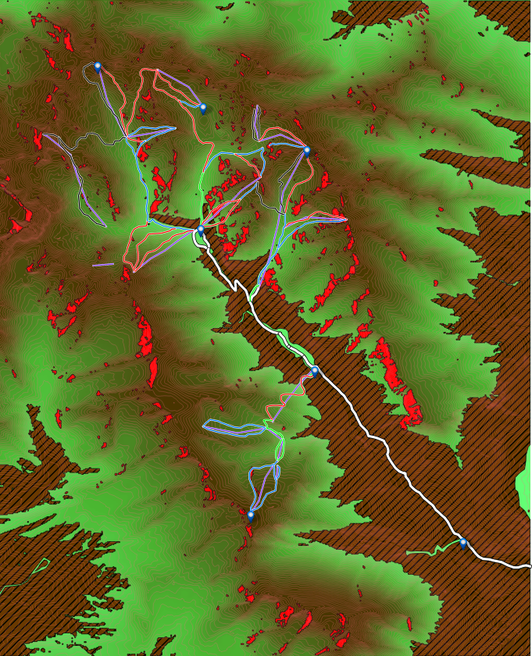

The above image was generated using raster data from the area. Aspect and Slope DEM was used to find west facing (225-315 degrees) slopes between 20 and 45 degrees. The resulting area is highlighted in red and shows areas that are at a higher risk of avalanches. Forested areas (brown) have also been added to indicate areas at less of a risk. Roads, bus routes / roads, ski slopes, ski lifts and met stations have also been added to show key areas that may be of greater concern.

# Part 4

# 

Proposed locations for new met stations are indicated within the orange buffers in the image above. These buffers were created by creating a fixed 5 km buffer around met stations and 3km buffers around roads and ski slopes. The buffers that were placed around the roads and the ski slopes were combined and the common area between the merged buffers and the met buffers is the resulting final buffer that is shown on the map (orange). Forested area is also shown on the map to indicate areas that met stations may not be suited to. Roads, ski slopes, ski lifts and met stations have all been added for context.